**An Official Website for Community Force for Common Good Incorporated – Calamba Chapter**

Presented to the Faculty of the

**College of Information Technology**

Saint Vincent College of Cabuyao

Mamatid, City of Cabuyao, Laguna

by:

**Batusis, Maria Abegail M.**

**Mechilina, Mark Russel A.**

**Villaluz, Mark Topher A.**

In Partial Fulfillment of the Requirements for the Degree of

**Bachelor of Science in Information Technology**

**April 2023**

i | P a g e

**CERTIFICATION**

The Capstone Project entitled, **AN OFFICIAL WEBSITE FOR COMMUNITY FORCE FOR COMMON GOOD INCORPORATED – CALAMBA CHAPTER** prepared and submitted by Maria Abegail M. Batusis, Mark Topher A. Villaluz, Mark Russel A. Mechilina, in partial fulfillment of the requirements for the degree of Bachelor of Science in Information Technology has been examined and is hereby recommended for acceptance and approval.

**ENGR. ROBERT ALLAN G. DIMARANAN**

*Date Research Instructor*

**APPROVAL SHEET**

Oral presentation of this website was attended by the undersigned panel of examiner on 23th of April, 2023 and was given the grade of .

**PANEL OF EXAMINERS**

**JEFFREY S. GOMEZ MOHAN WILLIAM SHARMA**

*Panel Panel*

**JOEMARI S. SABAO**

*Panel*

In Partial Fulfillment of the Requirements for the Degree of Bachelor of Science in Information Technology.

**ELVIRA P. LLANES, Ed.D**

*Dean*

ii | P a g e

**DEDICATION**

This research is wholeheartedly dedicated especially to all of our parents and family who support our bachelor’s journey financially, morally and emotionally. Their efforts and sacrifices brought to us as our inspiration to continue and finish our study no matter what hard times done during our schooldays.

To our friends, relatives and colleagues who also gave some advice and inspirational words that encourage us when there are times that we felt exhausted and failure.

To our Almighty God that gave us wisdom and knowledge that we used to accomplish this research. We know and claimed that all of these hardships and sacrifices are according to His plan.

iii | P a g e

**ACKNOWLEDGEMENT**

The researchers would like to express their sincere gratitude to all the people who became part of the accomplishment of this study. The success of this research would not be made possible without their support and assistance.

First and foremost, the researchers would like to thank God for His shower of blessings that helped them to complete their research successfully.

To **Ms. Elvira Llanes,** Dean, St. Vincent College of Cabuyao; for allowing the researchers to conduct the study.

To **Engr. Sheila Mae Bisnar,** our adviser, for helping the researchers with adequate information which are needed for the conduct of this research. The researchers were truly thankful for his guidance throughout the preparation of this research.

And lastly, to the respective families of each researcher, for giving them their unending love, encouragement, and overall support both morally and financially.

**The Researchers;**

iv | P a g e

**ABSTRACT**

v | P a g e

**TABLE OF CONTENTS**

**PRELIMINARIES Page**

Title Page……………………………………………………………………………. i

Certification……………………………………………….……………………….. ii

Dedication………………………………………………………………………… . iii

Acknowledgment…………………………………………................................. iv

Abstract………………………………………….…….….………………………. v

Table of Contents………………….…………………..………………………… vi

List of Figures……………………………….….…….…..……………………… ix

List of Tables………………………………………………............................... x

List of Appendices…………………………………….….……………………… xi

**CHAPTER 1 - INTRODUCTION**

BACKGROUND OF THE STUDY……………………………………………. 1

STATEMENT OF THE PROBLEM……………………………………………. 2

OBJECTIVE OF THE STUDY…………………………………………………. 3

SCOPE OF THE STUDY…………….. ………………………………………. 3

LIMITATION OF THE STUDY…………….. ………………………………… 3

SIGNIFICANCE OF THE STUDY ……………………………………………. 4

vi | P a g e

DEFINITION OF TERMS ……………………………………………………… 5

OPERATIONAL TERMS ………………………………………………

TECHNICAL TERMS ………………………………………………….

**CHAPTER 2**

REVIEW OF RELATED LITERATURE AND STUDIES …………………….8

FOREIGN STUDIES……………………………………………………… 8

LOCAL STUDIES………………………………………………………… 15

CONCEPTUAL FRAMEWORK…………………………................................ . 22

**CHAPTER 3**

RESEARCH METHODOLOGY…………………….…………………………. 27

SOFTWARE METHODOLOGY…………………….………………………… 27

THE PROCESS STEPS……………………………………………… 28

PROJECT DESIGN…………………………………………………………… 29

USER CASE DIAGRAM…………………………………………….. 29

SOFTWARE DEVELOPMENT…………………………….

PROJECT DEVELOPMENT……………………………….

SYSTEM DEVELOPMENT………………………..

FLOWCHART……………………………………………….

ACTIVITY DIAGRAM………………………………………

GANTT CHART FOR IMPLEMENTATION PLAN………

vii | P a g e

OPERATION PROCEDURE………………………………

TESTING PROCEDURE…………………………………..

**CHAPTE 4**

RESULT AND DISCUSSION……………………………..

SOFTWARE DESCRIPTION AND STRUCTURE……...

SOFTWARE CAPABILITIES……………………………..

SOFTWARE EVALUATION………………………………

RESPONDENTS OF THE STUDY……………..

PRESENTATION, ANALYSIS, AND INTERPRETATION OF DATA………….

**CHAPTER 5**

SUMMARY…………………………………………....…………………………. i

CONCLUSION…………………………….……………………………………. ii

RECOMMENDATION….………………………………………………………. iii

iv

v

vi

viii | P a g e

viii | P a g e

**LIST OF FIGURES**

**FIGURES**

2.1 Conceptual Framework of the Study………………

3.1 Rapid Application Mode…………………………….

3.2 Use Case Diagram for the Members Account……….

3.3 Use Case Diagram for the Admin Account…............

3.4 Use Case Diagram for the Non-Member Account

3.5 Flowchart Model for Member…………………….

3.6 Flowchart Model for Admin…………………….

3.7 Flowchart Model for Non-Member………………..

3.8 Activity Diagram for Members Account Registration……………………

4.1 Application Front Page Screen……………………………….

4.2 Registration Form Page……………………………………………

4.3 Logging-in and Log-out Page………………………………...

4.4 Member Dashboard……………………………….

4.5 Admin Dashboard………………………….….

ix | P a g e

**LIST OF TABLES**

**TABLES**

2.1 Likert Scale Measurement…………………………

4.1 Respondents of the Study……...………………….

4.2 Functionality Result Evaluation……………………

4.3 Content Result Evaluation…………………………

4.4 Aesthetic Result Evaluation……………………….

4.5 Service Security Result Evaluation………………

4.6 Total Average………………………….……………

x | P a g e

**LIST OF APPENDICES**

**APPENDICES**

Appendices A

Bibliography…………………………………………

Appendices B

Gantt Chart…………….……………………………

Appendices C

Survey Form.….……………………………………

Appendices D

Cost and Benefit Analysis…………………………

Appendices E

Screen Layout………………………………………

Appendices F

Certificates…………………………….……………

Appendices G

Curriculum Vitae……………………………………

66 – 68

69 – 70

71 – 73

74 – 77

78 – 86

87 – 90

91 – 94

xi | P a g e

**CHAPTER I**

**INTRODUCTION**

* 1. **Background of the Study**

The digital age has brought about new opportunities for Non-Governmental Organizations (NGO’s) to connect with the public, raise awareness about their cause, and mobilize support for their work. An Official website for an NGO can serve as a powerful tool for communication and engagement with a broad audience. However, creating an effective website requires careful planning and consideration of the organization’s goal, target audience, and the type of content that will be shared.

The Community Force for Common Good Incorporated – Calamba Chapter is a Non-Profit, Non-Governmental Organization (NGO), and has a scope of nationwide duly registered with the Securities and Exchange Commission (SEC) with Sec.Reg.No.CN201010744, with Accreditation and Memorandum of Agreement to the Community Defense Center (CDC) Philippine Army, Philippine National Police – Chaplain Service (PNP-CHS) Camp Crame, and Association of the Chiefs of Police of the Philippines (ACPPI) Camp Crame, Quezon City. This Organization has 3 divisions to provide a voluntarily service to God, community, and its people by proclaiming the Good News of God, humanitarian activities and outreach program,

1 | P a g e

and stand as Force-Multipliers of the Philippine National Police (PNP) for some of their operations.

By creating an official website for this organization, it will have a significant impact in multiple aspects, such as providing credible information, raising awareness and education people on certain topics, as well as connecting and uniting communities through communication and mobilization around shared interests and issues.

### Statement of the Problem

As of this moment, they are using some social media platforms to communicate and update some latest news and upcoming events and humanitarian service.

*Specific Problems:*

* + 1. How to reach-out more people on social media regarding with the problems to their community?
    2. How does a website for an organization help a lot for their humanitarian activities?
    3. What is the advantage of having an official website for an organization?

2 | P a g e

### Objectives of the Study

The study aims create and design an official website that is easily to use

as a medium of communication for the members of the organization to the community individuals and vice-versa. This project aims:

* + 1. To create an official website that can reach people and addressed their problems from their community.
    2. To make this organization known for their voluntarily service to the community. This includes:

1. Sharing the Word of God. The Philippine National Police – Chaplain Service conducts regular seminars and sessions to the respected areas by schedule.
2. Outreach programs like feeding program, community services (street cleaning), blood donations and seminars.
3. Assist and help Philippine National Police Personnel for their operations as part of being PNP Force-Multipliers.

3 | P a g e

* + 1. To make people aware for the organization’s role in their society.

### Significance of the Study

### An official website can be a valuable tool for various reasons. Some of the key benefits of having an official website includes:

### Communication – An official website can be used to share about the organization’s mission, vision, core values, activities and achievements. It also be used as a medium of communication with the minimal cost to reach a large number of people

### Transparency – Increase transparency and trust to an organization by providing the detailed information about the organization, activities, members, and finances. This is especially important for Non-Profit Organizations, which they can rely on public trust while achieving their goals.

### Marketing and Outreach – Can be used to promote their products, services, and events that can attract new customers and members. It can also be a useful tool for building a strong online presence, which can help to increase visibility and credibility of the organization regarding to its field.

4 | P a g e

### Fundraising and support – An official website could have a fund raising or donation page, which can help their organization regarding to their financial needs for their mobilization, programs and also providing a way to get support from their supporters local and international.

### Building a community – An official website can be used to build and engage a community supporter around the organization’s mission. It also serves as a platform to connect, collaborate, and share information.

### Scope and Limitation

### The study is focused on creating and designing an official webpage for Community Force for Common Good Inc. – Calamba Chapter that can be used as a valuable tool and medium of communication between members and non-members. The web based can be viewed by someone who is not an official member of the organization but is limited and other page of the site was hidden to secure the website. For members and administrator, they can log-in first with their authenticated e-mail address and also with their unique password for security purpose. They cannot view and visit the website without an Internet connection.

5 | P a g e

### CHAPTER 2

**RELATED LITERATURE AND STUDIES**

This chapter presents the review of related local and foreign literature written by authors whose writing articles have direct relation about the study.

### 2.1 Foreign Literature and Study

According to *Nazuk A, Shabbir J (2018), “A new disclosure index for Non-Governmental Organizations*”, NGOs possess the capability to influence public policy through the act of promoting a cause or position. This promotion can be executed through various means, and can utilize one or a combination of the following non-excluding methods: direct interaction with decision makers, influence through intermediaries, and utilizing the media. With the emergence of the internet and the World Wide Web, websites have emerged as a powerful tool for NGOs to utilize in their advocacy efforts.

Transparency not only concerns how decisions are made, but also who makes them. Studies have looked at the extent to which NGOs disclose information about diversity on their websites. Research has found that this is not a common practice and that only a small percentage of NGOs provide this type of information. However, NGOs can use their websites to present this type of information with more freedom and control and craft their public image. Additionally, the public can use as organization’s website to assess if diversity is acknowledged as an important aspect of the organization’s mission or values. *-Science Direct (April 2021).*

6 | P a g e

The article discusses how recent events have shown the connection between the internet and political action, but non-governmental organizations (NGO’s) still need to find effective ways to use the internet for human rights advocacy. It notes that many NGO’s have websites and use technology like social media, but they often just use the internet to support their existing programs and activities. The study looks at the websites of 100 human rights NGOs to understand how they currently use the internet and how their advocacy efforts could be improved. It also references existing literature about online activism and the difference between using the internet to support established strategies and using it in new and innovative ways. The study provides statistics on how NGO’s currently use the web and looks at examples of creative strategies. It concludes by making recommendations for how NGO’s can improve their online strategies for human rights advocacy. *– Lindsay N. Kingston, Kathryn R. Stam (23 January, 2013), “Online Advocacy: Analysis of Human Rights NGO Websites”*

According to *Daniel Kwame Ampofo Adjei et. al. (2016), in their article “Use of Social Networking Websites among NGOs in the Greater Accra Region of Ghana*”, NGOs in Ghana utilize social media platforms for a variety of reasons, such as building relationships with stakeholders, raising funds, and promoting the interests of vulnerable groups in society. A stepwise analysis was conducted to examine the factors that influence the extent to which NGOs in the Greater Accra region of Ghana use social media websites. The results showed that factors such as having a website, the perceived usefulness of social media, and the type of NGO where the main determinants of the level of usage of social networking websites among NGOs in the Greater Accra region of Ghana.

7 | P a g e

NGO networks have become a crucial tool for NGOs in Latin America. These networks play a significant role in advocating for the NGO sector, gaining public support, and improving the delivery of public goods and services. Therefore, understanding these networks is essential to understanding the broader NGO sector. The article examines how NGO networks use collective texts to spread and modify managerial practices. NGO networks use elements of managerialism and their adaptations to convey quality, gain recognition in social development, identify the strengths and weaknesses of the sector, and define civil society to gain sector legitimacy. Although the article examines managerialism from a critical point of view, it finds that understanding NGO networks and the spread and modification of NGO practices can provide insight into effective sources of sector legitimacy and help to strengthen the sector’s role in social development. - *Susan Appe (2016), “NGO Networks, the Diffusion and Adaptation of NGO Managerialism, and NGO Legitimacy in Latin America”*

8 | P a g e

Non-governmental organizations (NGOs) have become an important part in addressing economic, environmental, and social development issues. They play an increasingly important role in initiating, bringing together, connecting, and coordinating different actors in a social change process that emphasizes equity, long-term security, sustainably community, and inclusive human development over time and space. NGOs have major role in sustainable development at both national and international level and they also facilitate public and private sectors integrating sustainable development concerns into the decision-making process. Although the current studies on cross-sector social partnerships (CSSPs) recognize that partner diversity, particularly NGO involvement, may lead to more proactive outcomes, our understanding of the various roles played by NGOs in collaborative settings is still limited. While Social innovation and sustainable community development have gradually gained public attention and are discussed globally, our understanding of how NGOs facilitate such social change processes through the formulation and implementation of CSSPs remains limited. Therefore, the specific roles played by NGOs in social partnerships that promote sustainability have gained increased attention among scholars and practitioners. *- Xinya Yan, Haiying Lin, Amelia Clarke (2018), “Cross-Sector Partnerships for Social Change: The Roles of Non-Governmental Organizations”*

According to *Mohammad Muhyiddin Hassan, Khai Ern Lee, Mazlin Mokhtar (2018), in their article “Streamlining Non-Governmental Organizations’ programs towards achieving the sustainable development goals: A conceptual framework*”, The Sustainable Development Goals (SDGs) are global objectives set by the United Nations to tackle various social, economic, and environmental issues. Non-Governmental Organizations (NGOs) have been identified as key players in implementing these goals locally. As a result, research has shifted from a single-sector approach to a cross-sector approach. However, the varying capacity and institutional factors of NGOs can lead to uncertain impacts that are difficult to measure consistently. Many NGOs have continued using the single-sector approach used in the Millennium Development Goals, which may limit their contributions to achieving the SDGs. This paper proposes a framework for NGOs to align their programs with the SDGs through cross-sector partnerships and raising social awareness across multiple sectors, known as broadening social value.

9 | P a g e

This framework provides a basis for NGOs to plan their programs based on their capability and capacity to achieve the SDG’s targets.

According to *Meier Harald (2016), “Global Civil Society from Hyperlink Prospective: Exploring the Website Networks of International NGO”*, the topic of global civil society has received a lot of attention since the end of the Cold War, and it is closely related to discussions about globalization and the network society. The term “global civil society” is controversial and there is no universally accepted definition. It can be described as a social space that includes various networks of non-state and non-economic actors at a global level. International NGOs and global social movements are important parts of this concept. Some view international NGO’s as potential agents for promoting a fair and just world order. The websites of these organizations are useful for studying through hyperlink analysis for several reasons. They often serve as information platforms to present their work to a global audience, and they use the websites and connected social media as a way to communicate with members and those interested in their mission.

10 | P a g e

Additionally, international NGOs are often part of different types of networks such as global office networks, expert networks, grassroots networks, and strategic alliances with other organizations. The activities in these networks are reflected in part in the hyperlink of the organization’s websites.

According to *Mohammed Honinah & Wall Alhakimi (2021), in their article “Social Media Adoption in Yemeni Local NGOs”*,their study was focused on the use of social media by non-government organizations (NGOs) and its impact on their outreach and effectiveness. Social media use is growing rapidly as platforms offer excellent opportunities for organizations, including NGOs. To connect with communities, donors, and stakeholders, reduce costs and improve services. The study is based on a survey of 96 participants from 11 local NGOs in Yemen. The data collected was analyzed using descriptive statistics such as means and standard deviations, in order to examine the 6 Technology-Organization-Environment factors (Technological Factors: perceived benefit, compatibility, complexity; Organizational Factor: top management support; Environmental Factors: bandwagon pressure and competitive pressure).

11 | P a g e

The results of this study suggest that the factors (perceived benefit, compatibility, complexity, top management support, and competitive pressure) are important in the adoption of social media by NGOs. The study found that, among the factors, only bandwagon pressure was found to have no significant role in adoption of social media by NGOs.

This study provides a foundation for future research on social media adoption and also serves as a useful guide for NGOs that want to use social media effectively to benefit their organizations. It highlights the importance of considering factors such as the perceived benefits of social media, compatibility with the organization’s goals, complexity of use, support from top management and the pressure from competitors, when implementing social media strategies.

12 | P a g e

### 2.2 Local Literature and Study

This research aims to understand and identify the practices of social entrepreneurship among three non-governmental organizations (NGOs) in the Philippines. It argues that in order to be successful in the future, organizations must be adaptable, innovative, and entrepreneurial. This is particularly important in light of the uncertain financial climate, lack of government trust, aging population, more culturally diverse communities, and changes in funding. The study aims to critically examine these three cases of NGOs and their leaders in the Philippines to understand the traditions of social entrepreneurship they embody. -*(Duldulao, Glenda, May 2012)*

This passage discusses how the online communicative environment has the potential to revolutionize political discourse by providing a platform for marginalized groups, like indigenous communities from developing countries, to express themselves and participate in shaping their own identities and narratives. However, there are doubts about the true effectiveness of online spaces in empowering these groups. The author of the paper examines this issue using the ideas of James Scott and Andrew Feenberg about power dynamics and technology. The research conducted, including interviews and analysis of online space, focuses on the strategies and experiences of two indigenous groups in the Philippines, Tebtebba and Cordillera People’s Alliance, in using online spaces for activism. The paper argues that the use of online media by these groups is a delicate balancing act between accommodation and resistance and that they must weigh the potential risks and benefits of online spaces for their movement. *– Cheryll Ruth Soriano (2012)*

13 | P a g e

According to *Jolly Ann J. Flores and Janina Elyse A. Reyes (2022)*, the study aims to create a usability user interface design for charity drives, specifically for promoting and protecting the intangible cultures of indigenous tribes in the Philippines. The study aims to create an online donation platform (referred to as the Orion Giver application) that is functional, user-friendly, reliable, efficient, trendy, and enjoyable for users to interact with. The proposed design includes features such as the ability to start campaign, live streaming, a variety of donation categories, and the ability to upload featured stories to catch people’s attention.

The study also focuses on usability metrics according to ISO standards, which measure the effectiveness, efficiency, and satisfaction of the user interface. Additionally, the researches plan to use user’s evaluation methods to analyze the user experience and gather data to provide a user interface that is more suitable for users. The proposed design prioritizes the visual experience of the users and the goal is to unite people of all races worldwide through the power of storytelling.

According to *Mervi Pantti et al. (2015)*, the study looks at how aid organizations are using social media, specifically user-generated disaster appeal videos on Youtube, to communicate with the public and raise funds for disaster victims. It examines the ways in which these videos try to create a sense of empathy and connection with the victims, and how viewers respond to them. The article suggests that this type of citizen communication may be able to bypass distrust of traditional humanitarian organizations and promote a sense of global solidarity among viewers.

14 | P a g e

According to *Sandra Rodriguez (Dec. 2013),* to her article “*Making Sense of Social Change: Observing Collective Action in Networked Cultures”*, discusses the growing trend of studying how social media technologies are affecting the way people

interact and organize in relation to social change. There has been a significant amount of research in recent years on the role of ICTs (Information and Communication Technologies) in collective action and social movements, with a focus on how social media has become a crucial part of many transnational movements and social change projects. The research in this field encompasses theories from social movements, political science, and communication studies, suggesting that online activism and increasingly networked interactions are transforming the meanings and definitions of collective action and social change.

15 | P a g e

The article identifies three approaches used by scholars to make sense of these changes: studying the actual networking of actors, the diffusion of new repertoires and frames through networks, and understanding the new meanings conveyed within networked cultures. It concludes by suggesting that further research is needed to fully understand how actors define collective action and how they use social media tools in their efforts to bring about social change.

16 | P a g e

### Conceptual Framework

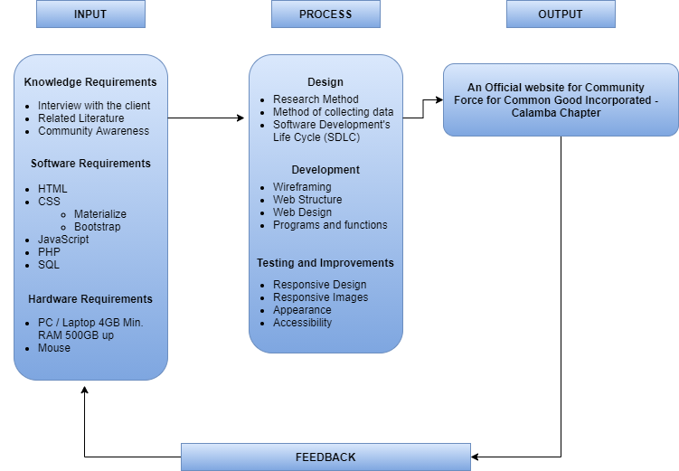

Figure 2.1. *Conceptual Framework*

17 | P a g e

This study adopted the “Input-Process-Output” (IPO) model of the project upon its creation. The Input Requirements are classified as to Knowledge Requirements, Software Requirements, and Hardware Requirements.

The Knowledge Requirements includes: Interview with the client for their profile and problem statement, Related Literature for references and study, and Community Awareness about the study.

Software Requirements Includes: HTML as Markup Language for the structure of the website, CSS for stylesheet, Materialize CSS and Bootstrap CSS for the design and appearance, JavaScript for initialization, PHP for functions, and SQL for Database.

Hardware Requirement is a PC / Desktop Computer / Laptop, with the minimum specification of 4GB RAM, at least 500GB HDD for its Memory, and mouse for cursor pointer.

For its Process, there are three stages: the Design which the Research method and collection of data for gathering some information and the whole process are sequenced according to its Software Development Life Cycle (SDLC).

Development Stage includes: Wireframing, Web Structuring, Web Designing, and Programs and Functions. Testing and Improvement includes the Responsiveness of the Design and Images, Appearance, and Accessibility. It is also the last stage of the process where the project needs an improvement when error or problem occurs.

18 | P a g e

* 1. **Definition of Terms**

The following terms were defined according to their use in the study and provided necessary information in the operation and technicality.

**1.6.1 Operational Terms**

**About us page** – A page that provides information about the organization’s history, mission, and team.

**Domain Name** – Is what the people type into their browsers address bar to reach the organization’s website.

**Footer** – The section at the bottom of a website that typically contains copyright information, legal disclaimers, and links to other pages.

**Homepage** – The main page of a website that serves as an entry point of visitors.

**Hosting** – The service that allows a website to be accessible on the internet by storing its files on a server.

**Mobile-Responsive Design** – The design of a website that automatically adjusts to the size and resolution of the user’s device, including smartphones and tablets.

**Navigation** – The design and organization of menus and links on a website to help users find information and move through the site.

19 | P a g e

**Non-Government Organization (NGO)** – A non-profit organization that operates independently from any government and is typically focused on addressing social or political issues.

**Official Website** – This refers to a digital representation of the organization that allows sharing information, offer services and products and provide as a mean of communication for its target audience.

**User Experience (UX)** – The overall experience of a person using a particular product, system or service, often used to refer to the ease of use, accessibility, and satisfaction of a website.

**Website** – A collection of related webpages, including a homepage, that are typically accessed via a web browser and are located on a single domain.

**1.6.2 Technical Terms**

**Application Programming Interface (API) –** A set of protocols and tools for building software and applications, often used to integrate different systems and services on a website.

**API Integration –** The process of connecting different software systems or services using an Application Programming Interface (API)

**Content Management System (CMS) –** A software application that allows users to create, manage, and publish digital content, typically in the form of websites.

20 | P a g e

**Database –** A system for organizing and storing data, such as user information, content, and analytics for a website.

**Hypertext Markup Language (HTML) –** Used to create the structure and content of the web pages.

**Hypertext Preprocessor (PHP) –** An open-source server -side scripting language and is often used in combination with HTML, CSS, and Java script to create dynamic and interactive websites. It is particularly useful for dynamic content and generating HTML code.

**Responsive Design –** The design approach that ensures a website is optimized for different screen sizes and devices, allowing for a consistent user experience across platforms.

**Responsive Images –** Images that are optimized to load quickly and look good on different devices, screen sizes, and resolutions.

**Server –** A computer or device that stores and provides access to files and data for a website.

**Web Accessibility –** The practice of designing and developing websites that can be accessed and used by people with disabilities, such as visual,

or hearing impairments.

21 | P a g e

### CHAPTER III

**RESEARCH METHODOLOGY**

### Software Methodology Used

Rapid Application Development (RAD) is a software development methodology that uses minimal planning in favor of rapid prototyping. A prototype was a working model that has a functional equivalent to a component of the proposed project.

**Requirements Planning**

22 | P a g e

Figure 3.1 *Rapid Application Model*

**Implementation**

**3.1.1 The Process Steps**

### Phase 1: Planning Stage

### In this phase, planning and gathering data is implemented by conducting an interview to the client for features and design of the project they needed.

### Phase 2: Construction Stage

### In this phase, wireframing and coding is implemented with the help of different software that initialize and build the structure of the project. This stage defines the research methodology RAD as we focus more on the creation of the project than planning.

### Phase 3: Design Stage

### This phase was focused on the details, design and layout of the project.

### Phase 4: Implementation Stage

### In this phase, implementing features and some functions of the project has been done. This phase is also an early stage of Operation and Testing Procedure by undergoing a trial-and-error process.

23 | P a g e

### 

### Phase 5: Operation and Testing Procedure

### This phase is the final stage where the project was ready to be tested by the client and respondents and also to gather their feedbacks regarding to their interaction and experience to the said project. Their feedbacks were the most important part for deep analyzation and improvements if there is an error or problem.

### 3.2 Project Design

### 3.2.1 Use Case Diagram

Log-in & Log-out

Members Account

**Member System**

### C:\Users\Owner\Downloads\employee-system\employee-system\assets\avatar.png

Profile

Message History

**Dashboard**

**MEMBER**

Settings

Review Page Content

**User Experience**

### Figure 3.2 *Use Case Diagram for the Member Account*

25 | P a g e

In Figure 3.2, the use case diagram for the members account is illustrated. The members account can access the system log-in and log-out their account, followed by dashboard section the member can also see their profile, message history, and settings. A member can also review page content.

Admin Account

**Admin System**

Log-in & Log-out

### C:\Users\Owner\Downloads\employee-system\employee-system\assets\admin.png

**ADMIN**

Insert New Serial ID

Page Profile

**Dashboard**

Message History

Content

### Figure 3.3 *Use Case Diagram for the Admin Account*

In Figure 3.3, the use case diagram for admin account is illustrated. The admin account can access the system and, log in and log out. Followed by dashboard section the admin can also access the main function of the system where you can visit the page profile, inserting new serial id number of the member, message history and some sort of page content.

26 | P a g e

### C:\Users\Owner\Downloads\employee-system\employee-system\assets\avatar.png

**Index Web Page**

**Page**

**Registration**

**NON-MEMBER**

**System**

**Index Content**

### Figure 3.4 *Use Case Diagram for the Non-Member Account*

### In Figure 3.4, the use case diagram for the non-member is illustrated. The non-member can see the home page of the website. The non-member can try the free registration of the website so they can become official member, other features is they can also see the full index content of the website.

27 | P a g e

**3. 3 SOFTWARE DEVELOPMENT**

The proponents used HTML for structure of the website, CSS in web designing, JavaScript for initialization of the design and features, PHP for the functions, and SQL for database.

**3.4** **PROJECT DEVELOPMENT**

The following step-by-step procedure was done during the fabrication of the system.

**1.** Create a Website for An Official Website for Community Force for Common Good Incorporated – Calamba Chapter

**1.1** Created the Case Activity Diagram Illustrated in Figures 3.2, Figure 3.3, and Figure 3.4

**2.** Server

**2.2** XAMPP

**3.4.1 SYSTEM DEVELOPMENT**

1. HTML, CSS, and XAMPP were used in software development to program, design, and create a database for the website.

28 | P a g e

2. The use case diagram is shown in Figure 3.2, Figure 3.3, and Figure 3.4

3. The flowchart diagram is illustrated in Figure 3.5 and 3.6.

**3.5 Flowchart**

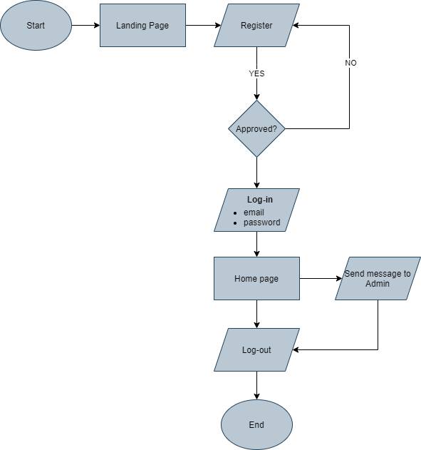

Figure 3.5 *Flowchart Model for Member*

### In Figure 3.5, The flowchart diagram model for member user is illustrated, starting from landing page direct to registration then answering yes if it is approved and then direct log-in to their accounts and it is directed to the home page. The member’s dashboard will display the member’s profile and also the announcements for upcoming projects and activities of the organization, they can also directly send a message to the administrator for some concerns and then log-out.

29 | P a g e

Figure 3.6 *Flowchart Model for Admin*

### In Figure 3.6, The flowchart diagram model for administrator of the website is illustrated from the only person who is able to access all the features of the website.

30 | P a g e

### All the messages received from member user and sign-up approval will be directed to its admin’s dashboard. All the approved members account information will be kept on the website’s database. The administrator can also update and upload latest news, videos, images and live recordings and displayed it to the homepages of the member user and non-member user.

Figure 3.7 *Flowchart Model for Non-Member User*

In Figure 3.6, The flowchart diagram model for non-member of the website is illustrated starting fromlanding page direct to see the community page followed by you can send message to the admin. The user can also go back to the home page then direct to see the about us page then log-out.

31 | P a g e

**3.6 Activity Diagram**

SYSTEM

MEMBER

Registration

Validation

Notify admin for user request

Log-in

Members Profile

Save Data

Figure 3.8 *Activity Diagram for Members Account Registration*

Figure 3.8 illustrates the activity diagram for the member’s account registration form, starting from sign-up registration, the member can now check the notification if there request and decide to accept or decline. Upon approval followed by the log-in the member can now easily see the profile posted on the dashboard of the web application system.

32 | P a g e

**3.7 Gantt Chart**

Gantt chart shows the implantation plan of the system (See Appendix B). Fourteen weeks were allotted for the completion of the research. The first three weeks were allotted to carry out the communication plan, research, company search, interviews, and brainstorming were conducted. The modeling plan is carried out in the next fourth to the fifth week where the data flow diagram and its requirements are determined, the next week is spent for planning the development of the system and tested in the fourteenth week the research was completed.

**3.8 Operation Procedure**

Listed below are the step-by-step procedures in operating the website application system for An Official Website for Community Force for Common Good Incorporated.

Member Account

1. Open the application and choose between sign-in and sign-up.

2. Click the member account

3. Enter a valid user name, and password.

33 | P a g e

4. The dashboard will then appear where the member account has access to the following functions:

1. Members data
2. Profile
3. Message History
4. Setting

Administrator Account

1. Open the application and choose between sign-in and sign-up.

2. Click the admin account

3. Enter a valid user name, and password

4. The dashboard will then appear where the admin account has access to the following functions:

1. Member request
2. Profile
3. View Community
4. Setting

34 | P a g e

**3.9 Testing Procedure**

The proponents conducted testing procedures to ensure the performance of the Community Force for Common Good Incorporated. Alpha test or initial testing and the Beta test which is the final testing are conducted correspondingly to make sure that the web application system is working as intended by the proponents.

***Alpha test***

Alpha test or the initial testing of the system, the proponents test first on the mobile phone if the web application can be applied to the phone or the appearance

of the system are visible on the mobile phone. The proponents tested the web application system to see the bugs and errors that appear on the system, and the buttons are also tested if it functions accordingly to the proponent’s needs.

***Betta test***

This is the final test which is the actual testing of the overall system, the simulation that will be conducted by the proponents to ensure all the designs, the functionality of buttons, and the database are responding correctly. In controlling the database, the admin is only allowed to control the information that saves into the database and ensure the information is secure. It is also tested on the mobile phone if it works correctly same in other devices.

35 | P a g e

### 3.10 Evaluation Procedure

The proponents conducted survey to determine and evaluate the web application’s functionality, content, aesthetics, and security functions. With the use of the survey method, every function and content of the web application is analyzed to determine whether it is still in need of improvement or properly functioning as intended by the proponents. In the Table 4.1, the proponents utilized the 5-point Likert Scale System to evaluate the web application software.

Table 4.1 *Likert Scale Measurement*

|  |  |  |
| --- | --- | --- |
| **Value** | **Mean** | **Description** |
| 5 | 4.51 – 5.00 | Outstanding |
| 4 | 3.51 – 4.50 | Very Satisfactory |
| 3 | 2.51 – 3.50 | Satisfactory |
| 2 | 1.51 – 2.50 | Unsatisfactory |
| 1 | 1.00 – 1.50 | Poor |

36 | P a g e

The formula for weighted mean will be used in evaluation, for the proponents to be able to determine the average degree of opinion or the respondents.

Formula:

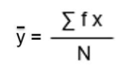

# Where:

37 | P a g e

# **Chapter IV**

# **RESULT AND DISCUSSION**

## This chapter presents the detailed content and structure of the software and as well as the capabilities of the system, the evaluation of the system software is also presented with the use of the post-survey evaluation result to determine the functionality, content, aesthetic, and security of the web application system software.

## Software Description and Structure

## The website application software of the proponents named Community Force For Common Good Incorporated – Calamba Chapter is a website system, and its main function is to build process that’s polished and hassle-free, it helps automate the tedious, repetitive tasks in your application review and workflow process. Save time and focus on what matters most, maximizing your impact. Custom branded portals to easily build and collect applications, assign reviews, and capture the feedback you need to make decisions and drive your campaign forward.

38 | P a g e

## 

## Figure 4.1 *Application Front Page Screen*

## Upon opening of the web application, a brief screen will appear before loading the front page of the web application, the user has option to sign-in, if they already have account and sign-up to create a member account for new users.

39 | P a g e

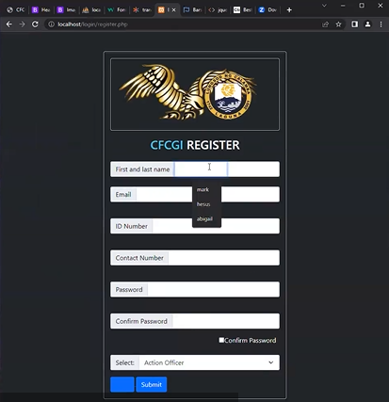

Figure 4.2 *Registration Form Page*

In the figure above, the registration page is illustrated, for a successful access of the web application, the user must provide a valid or registered email address and password according to your google mail. The user has the option to recover and change their forgotten password by clicking the “Forgot Password” option. For the registration form option, the required details are name, email address, ID number, contact number and password for a successful account registration.

40 | P a g e

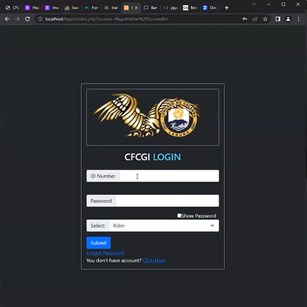

## 

## Figure 4.3 *Logging-in and Log-out Page*

## In the figure above, the log-in page is illustrated, for a successful access of the application, the user must provide an ID number and password. The user has the option to choose whether he/she a rider, action officer, or chaplain.

41 | P a g e

## 

## Figure 4.4 Member Dashboard

## In Figure 4.4, the dashboard for members account is illustrated, after a successful log-in, the member can access the dashboard where they can access the profile, message, setting and log-out.

42 | P a g e

## 

## Figure 4.4 *Admin Dashboard*

## In the figure above ------

43 | P a g e

## Software Capabilities

## The web application system is designed for the organization, that will have a significant impact in multiple aspects, with the help of providing credible information, raising awareness and education people on certain topics, as well as connecting and uniting communities through communication and mobilization around shared interests and issues. The whole information about the website is much faster compared to the traditional way which is not convenient and risky to go outside since we still in pandemic situation.

## 4.3 Software Evaluation

**4.3.1 Respondents of the Study**

|  |  |  |  |  |  |  |  |  |
| --- | --- | --- | --- | --- | --- | --- | --- | --- |
| **RESPONDENTS** | | | | | | | | **Overall** |
| **Rider** | | **Action Officer** | | **Chaplain** | | **TOTAL** | |
| **Male** | **8** | **Male** | **10** | **Male** | **9** |  |  | **50** |
| **Female** |  | **Female** | **9** | **Female** | **14** |  |  |

*Table 4.2 Respondents of the Study*

Table 4.2 illustrates the breakdown of the respondents in the survey evaluation. The chosen categories of respondents are the people who work inside the facility the riders, action officer and chaplain officer and the total number of our respondents is fifty (50) with twenty-five (27) male and twenty-five (23) females.

44| P a g e

The following statistical tools will be used in the evaluation and statistical treatment of the data. In evaluating the percentage of the demographic profile of respondents, counts and percentage ratings will be applied.

**Formula:**

%= F/N x 100

**Where:**

% = Percentage

F = Frequency Counts

N = Total Number of Respondents

**4.3.2 Presentation, Analysis, and Interpretation of Data**

The result of data gathered from the survey questionnaires will be illustrated in this chapter. There are five main categories for the post-survey evaluation and each category is presented along with the summary of the result for the analysis and presentation of data.

45| P a g e

|  |  |  |  |
| --- | --- | --- | --- |
| **INDICATORS** | **MEAN** | **PERCENTAGE** | **VERBAL**  **INTERPRETATION** |
| **A. FUNCTIONALITY** |  |  |  |
| 1. User interface is pleasant to use | **46.8** | **93.60%** | VERY GOOD |
| 2. User-friendliness of application | **44.8** | **89.60%** | VERY GOOD |
| 3. Function consistency of system flow | **45.8** | **91.60%** | VERY GOOD |
| 4. The system functionality will go the same | **48** | **96%** | VERY GOOD |
| 5. Application buttons are responding accordingly | **45** | **90%** | VERY GOOD |
| 6. Functions response speed | **4.24** | **84.8%** | VERY GOOD |
| 7. All system functions is working | **4.44** | **88.80%** | VERY GOOD |
| **AGGREGATE ASSESSMENT** | **34.15** | **90.63%** | VERY GOOD |

Legend: 5.0 – 4.5 Excellent; 4.49 – 3.5 Very Good; 3.49 – 2 .5 Good; 2.49 – 1 .5 Fair; 1.49 – 1.0 Poor  
*Table 4.3 Functionality Result Evaluation*

Table 4.3 aims to evaluate the functionality of An Official Website for Community Force for Common Good Incorporated application. According to the data gathered presented above, the respondents think that the real-time updates of the system shall be applauded the most as it gathered a weighted mean of 48. This equivalent to 96% in percentage and can be categorized under Very Good. Meanwhile, the function response speed got the lowest mean of 4.24 which can be equated to 84.8%. However, the said indicator can be assessed under the category of Very Good as well.

This led to the aggregate assessment of 34.15. On percentage, this is equivalent to 90.63% is rated a Very Good.

46| P a g e

|  |  |  |  |
| --- | --- | --- | --- |
| **INDICATORS** | **MEAN** | **PERCENTAGE** | **VERBAL**  **INTERPRETATION** |
| **B. CONTENT** |  |  |  |
| 8. Content style of website application | 48 | 96% | VERY GOOD |
| 9. Engaging content of website application | 46 | 92% | VERY GOOD |
| 10. Presentation of personal profile information | 41 | 82% | VERY GOOD |
| 11. General content comprehensiveness | 40 | 80% | VERY GOOD |
| 12. Complete website content | 46 | 92 | VERY GOOD |
| 13. All system function are working | 4.48 | 89.6% | VERY GOOD |
| **AGGREGATE ASSESSMENT** | **37.58** | **89%** | VERY GOOD |

Legend: 5.0 – 4.5 Excellent; 4.49 – 3.5 Very Good; 3.49 – 2 .5 Good; 2.49 – 1 .5 Fair; 1.49 – 1.0 Poor  
*Table 4.4 Content Result Evaluation*

Table 4.4, aims to assess the content of An Official Website for Community Force for Common Good Incorporated. Having a total of 48 weighted mean, the 8th indicator which talks about the Content style of website application got a Very Good rating as well, with 96% percentage. On the other hand, the 11th indicator under the General content comprehensiveness cluster got the lowest mean of 40, yet still was evaluated as Very Good. The said weighted mean can be transmuted to 80% in percentage.

Overall, the aggregate assessment has then gathered a total mean of 37.58, and 89% percentage. This similar to Very Good in verbal interpretation.

47| P a g e

|  |  |  |  |
| --- | --- | --- | --- |
| **INDICATORS** | **MEAN** | **PERCENTAGE** | **VERBAL**  **INTERPRETATION** |
| **C. AESTHETIC** |  |  |  |
| 14. Font style used in website application | 49 | 98% | VERY GOOD |
| 15. Font size use in website application | 42 | 84% | VERY GOOD |
| 16. Color theme of website application | 44 | 88% | VERY GOOD |
| 17. Appropriate utilization of logos | 46 | 89.2% | VERY GOOD |
| 18. Appropriate utilization of images | 44.6 | 89.2% | VERY GOOD |
| 19. General layout of user | 4.44 | 88.8% | VERY GOOD |
| **AGGREGATE ASSESSMENT** | 38.34 | 90% | VERY GOOD |

Legend: 5.0 – 4.5 Excellent; 4.49 – 3.5 Very Good; 3.49 – 2 .5 Good; 2.49 – 1 .5 Fair; 1.49 – 1.0 Poor  
*Table 4.5 Aesthetic Result Evaluation*

Table 4.5, the aesthetic was measured. As revealed, the respondents had one highest response for the indicators presented above. This led to the 14th indicator to gather the highest weighted mean of 49 which can also be assessed as Very Good in verbal notation. Meanwhile, the 15th indicator got the lowest mean of 42 and was categorized under Very Good as well.

With these being said, the aggregate assessment of 38.34 was concluded. This is the same with 90% in percentage and Very Good in verbal representation.

48| P a g e

|  |  |  |  |
| --- | --- | --- | --- |
| **INDICATORS** | **MEAN** | **PERCENTAGE** | **VERBAL**  **INTERPRETATION** |
| **D. SERVICE SECURITY** |  |  |  |
| 20. Personal information privacy is safe | **43** | **86%** | VERY GOOD |
| 21. Security during answering the personal information | **41.8** | **83.60%** | VERY GOOD |
| 22. Details provide during connecting the system | **39.6** | **79.20%** | VERY GOOD |
| 23. Security of personal information available from gadgets | **43.6** | **87.20%** | VERY GOOD |
| 24. Over all safeness/ security in using the system | **40.4** | **80.80%** | VERY GOOD |
| 25. Unique user and passwords are given by the admin for the security of members information leak | 44.6 | 89.2% | VERY GOOD |
| **AGGREGATE ASSESSMENT** | **42.17** | **84%** | VERY GOOD |

Legend: 5.0 – 4.5 Excellent; 4.49 – 3.5 Very Good; 3.49 – 2 .5 Good; 2.49 – 1 .5 Fair; 1.49 – 1.0 Poor  
 *Table 4.6 Service Security Result Evaluation*

Table 4.6, meanwhile, tabulates the data gathered to be able to assess of a website for community force application. Unique user and passwords are given by the admin for the security of members information leak is accurate and correct got the highest weighted mean of 44.6 in terms of security. This means that it has an outstanding 89.2% percentage and a Very Good rating for verbal notation. On the other hand, safety of details provided during connecting the system is the lowest weighted mean of 39.6. Although still classified under the Very Good category, this indicator is said to acquire a 79.20% percentage only.

The aggregate assessment has then convened a total of 42.17 which can be equated to 84% and Very Good in verbal assessment.

49| P a g e

|  |  |  |  |
| --- | --- | --- | --- |
| **INDICATORS** | **MEAN** | **PERCENTAGE** | **VERBAL INTERPRETATION** |
| A. Functionality | ***34.15*** | ***90.63%*** | VERY GOOD |
| B. Content | ***37.58*** | ***89%*** | VERY GOOD |
| C. Aesthetic | ***38.34*** | ***90%*** | VERY GOOD |
| D. Service Security | ***42.17*** | ***84%*** | VERY GOOD |
| **Aggregate Assessment** | ***38.06*** | ***88%*** | VERY GOOD |

*Table 4.7 Total Average of Weighted Mean*

Therefore, in the table 4.7 below, illustrates the over-all weighted mean of 38.06 with 88% and Very Good in verbal interpretation in the study entitles a web community force for common good incorporated application in terms of functionality, content, aesthetic, and service security.

50| P a g e

**CHAPTER V**

**SUMMARY, CONCLUSION, AND RECOMMENDATION**

**5.1 Summary**

The proponents developed a website application for community development to improve the current situation of the facility, with the help of the technology. In the development process of this research, the proponents used the *Conceptual Framework Model (****See Figure 2.1)*** *a*s the guide in the step-by-step planning and execution for the whole research, the proponents also created a *Gannt Chart* for an effective *Time Management (****See Appendix A)***, and as planned, the research began last June 2022 and planned to finish it on or before April 2023. The processing was executed smoothly, and the research was concluded in the target completion date. For the construction of the system, the proponents used the *Rapid Action Model* ***(See Figure 3.1)***, and planned processing steps are *Planning, Design & Coding and Implementation.*

The project’s *Feasibility, Cost Benefit* was also analyzed, and the costs in utilizing the system is determined as well as all benefits that will occur in the future, then the two aspects were compared, and the result was positive ***(See Appendix C)*** given that Return of Investment will be up to __ in the third year and __ in the fifth year.

51| P a g e

**5.2 Conclusion**

Given the *Summary of Findings* the proponents conclude that the website application system for An Official Website for Community Force for Common Good Incorporated – Calamba Chapter has a potential to improve the current situation of the community development in the country given that in all existing website application system on the internet, considering that the official website application is very common in most areas in the country.

The website application for community development could be defined as indigenous development which involves community participation to enhance peace and progress of the community and its people. The dimensions of community development are full community participation, bottom-up development strategy, solving felt needs of community, community program, program execution, interpretation of local knowledge, culture, norms and values of the community, interaction with the social environment, time line execution of community projects.

52| P a g e

**5.3 Recommendation**

The following items are the proponent’s recommendations for the future improvement and development of the proponent’s official website application system for Community Force for Common Good Incorporated – Calamba Chapter.

* Further improvement for the website application regarding on the contents that will post and include of the community service.
* Further enhancement of the account feedback rating field, for a more specific and detailed feedback, security and recommendation from the user account.
* Inclusion of registration option of the non-member in website application system who wants to be part of the community service.

53| P a g e

**Appendix A**

Bibliography

54| P a g e

**Bibliography**

55| P a g e

**Appendix B**

Gantt Chart

56| P a g e

**GANTT CHART**

**First Semester AY 2021-2022**

Programmer: Villaluz, Mark Topher

System Analyst: Batusis, Maria Abegail M. System Analyst: Mechilina, Mark Russel

57| P a g e

|  |  |  |  |  |  |  |  |  |  |  |  |  |  |
| --- | --- | --- | --- | --- | --- | --- | --- | --- | --- | --- | --- | --- | --- |
| **PROCESS** | | | | | **TIMELINE** | | | | | | | | |
| ***FIRST SEMESTER AY 2021-2022*** | | | | | | | | |
| **ACTIVITY** | **IN-CHARGE** | **START DATE** | **COMPLETION DATE** | **PROGRESSS** |  |  |  |  |  |  |  |  |  |
| 1. **COMMUNICATION** | | | | 100% | | | | | | | | | |
| 1.Communication plan |  |  |  | 100% |  |  |  |  |  |  |  |  |  |
| 2.Interview/Research |  |  |  | 100% |  |  |  |  |  |  |  |  |  |
| 3.Brainstorming |  |  |  | 100% |  |  |  |  |  |  |  |  |  |
| 1. **PLANNING** | | | | 100% | | | | | | | | | |
| 4.Observations |  |  |  | 100% |  |  |  |  |  |  |  |  |  |
| 5.Project Charter |  |  |  | 100% |  |  |  |  |  |  |  |  |  |
| 6.Feasibilty Study |  |  |  | 100% |  |  |  |  |  |  |  |  |  |
| 7.Final Project Plan |  |  |  | 100% |  |  |  |  |  |  |  |  |  |
| 1. **MODELING** | | | | 100% | | | | | | | | | |
| 8.Data Flow Diagram |  |  |  | 100% |  |  |  |  |  |  |  |  |  |
| 9.Requirements |  |  |  | 100% |  |  |  |  |  |  |  |  |  |
| 1. **CONSTRUCTION** | | | | 100% | | | | | | | | | |
| 10.System Design |  |  |  | 100% |  |  |  |  |  |  |  |  |  |
| 11.Coding |  |  |  | 100% |  |  |  |  |  |  |  |  |  |
| 12.Debugging |  |  |  | 100% |  |  |  |  |  |  |  |  |  |
| 13.Initial Testing |  |  |  | 100% |  |  |  |  |  |  |  |  |  |
| 14.Documentation |  |  |  | 100% |  |  |  |  |  |  |  |  |  |
| 15.Final Testing |  |  |  | 100% |  |  |  |  |  |  |  |  |  |
| 1. **DEPLOYMENT** | | | |  | | | | | | | | | |
| 16. Construction Complete |  | - |  | 100% |  |  |  |  |  |  |  |  |  |
| 17. Installation |  | - | - | 0% |  |  |  |  |  |  |  |  |  |
| 18. Maintenance |  | - | - | 0% |  |  |  |  |  |  |  |  |  |

Legend: (In-Charge) **System Analyst Programmer Both**

58| P a g e

**GANTT CHART**

**Second Semester AY 2022-2023**

Programmer: Villaluz, Mark Topher

System Analyst: Batusis, Maria Abegail M. System Analyst: Mechilina, Mark Russel

|  |  |  |  |  |  |  |  |  |  |
| --- | --- | --- | --- | --- | --- | --- | --- | --- | --- |
| **PROCESS** | | | | | **TIMELINE** | | | | |
| ***SECOND SEMESTER AY 2022-2023*** | | | | |
| **ACTIVITY** | **IN-CHARGE** | **START DATE** | **COMPLETION DATE** | **PROGRESSS** | **Jan. 17-Jan 28** | **Feb 1- Feb 11** | **Feb 13- Feb 25** | **Mar 6- Mar 18** | **Mar 20- Mar 31** |
| 1. **COMMUNICATION** | | | | 100% |  | | | | |
| 1.Communication plan |  |  |  | 100% |  |  |  |  |  |
| 2.Interview/Research |  |  |  | 100% |  |  |  |  |  |
| 3.Brainstorming |  |  |  | 100% |  |  |  |  |  |
| 1. **PLANNING** | | | | 100% |  | | | | |
| 4.Observations |  |  |  | 100% |  |  |  |  |  |
| 5.Project Charter |  |  |  | 100% |  |  |  |  |  |
| 6.Feasibilty Study |  |  |  | 100% |  |  |  |  |  |
| 7.Final Project Plan |  |  |  | 100% |  |  |  |  |  |
| 1. **MODELING** | | | | 100% |  | | | | |
| 8.Data Flow Diagram |  |  |  | 100% |  |  |  |  |  |
| 9.Requirements |  |  |  | 100% |  |  |  |  |  |
| 1. **CONSTRUCTION** | | | | 100% |  | | | | |
| 10.System Design |  |  |  | 100% |  |  |  |  |  |
| 11.Coding |  |  |  | 100% |  |  |  |  |  |
| 12.Debugging |  |  |  | 100% |  |  |  |  |  |
| 13.Initial Testing |  |  |  | 100% |  |  |  |  |  |
| 14.Documentation |  |  |  | 100% |  |  |  |  |  |
| 15.Final Testing |  |  |  | 100% |  |  |  |  |  |
| 1. **DEPLOYMENT** | | | |  |  | | | | |
| 16. Construction Complete |  | - |  | 100% |  |  |  |  |  |
| 17. Installation |  | - | - | - |  |  |  |  |  |
| 18. Maintenance |  | - | - | - |  |  |  |  |  |

Legend: (In-Charge) **System Analyst Programmer Both**

59| P a g e

**Appendix C**

Survey Forms

60| P a g e

|  |  |  |  |  |  |
| --- | --- | --- | --- | --- | --- |
| 1. **INTERNET / MOBILE DATA** |  |  |  |  |  |
| 1. Website availability when you use to log in |  |  |  |  |  |
| 2. Signal interruption when using the portal |  |  |  |  |  |
| 3. Website loading speed using mobile data or Internet connection |  |  |  |  |  |
| 4. Time consume using portal |  |  |  |  |  |
| 5. Ability to see the details contained in the website application |  |  |  |  |  |
| 6. Ease of having a manual |  |  |  |  |  |
| 7. Easy to use |  |  |  |  |  |
| **AVERAGE:** |  | | | | |
| 1. **EXPERIENCE** |  |  |  |  |  |
| 1. Capturing attention because of the layout |  |  |  |  |  |
| 2. Retaining attention |  |  |  |  |  |
| 3. Reduce the time to get a manual memo at the office |  |  |  |  |  |
| 4. No hassle when entering the login portal |  |  |  |  |  |
| 5. Make sure the security of your personal information |  |  |  |  |  |
| 6. Devise visibility of the website application |  |  |  |  |  |
| **AVERAGE:** |  | | | | |
| 1. **CONTENT** |  |  |  |  |  |
| 1. Design enhancement |  |  |  |  |  |
| 2. Effectiveness of portal using technology |  |  |  |  |  |
| 3. Readable website content |  |  |  |  |  |
| 4. Security when opening your account |  |  |  |  |  |
| 5. The user interface is pleasant to use |  |  |  |  |  |
| 6. Properly understand the content of the website |  |  |  |  |  |
| **AVERAGE:** |  |  |  |  |  |
| 1. **FEEDBACK** |  |  |  |  |  |
| 1. The website application functionality has no error at all |  |  |  |  |  |
| 2. Functions response speed |  |  |  |  |  |
| 3. Presentation in personal information |  |  |  |  |  |
| 4. Engaging the portal content |  |  |  |  |  |
| 5. Appropriate utilization of background |  |  |  |  |  |
| **AVERAGE:** |  |  |  |  |  |

**PRE-SURVEY FORM**

61| P a g e

|  |  |  |  |  |  |
| --- | --- | --- | --- | --- | --- |
| **CRITERIA** | **5** | **4** | **3** | **2** | **1** |
| 1. **FUNCTIONALITY** |  |  |  |  |  |
| 1. User interface is pleasant to use |  |  |  |  |  |
| 2. The application buttons respond accordingly |  |  |  |  |  |
| 3. Properly understand the content of the system |  |  |  |  |  |
| 4. The system functionality will go the same |  |  |  |  |  |
| 5. User-friendly website |  |  |  |  |  |
| 6. Functions response speed |  |  |  |  |  |
| 7. All system functions is working |  |  |  |  |  |
| **AVERAGE:** |  | | | | |
| 1. **CONTENT** |  |  |  |  |  |
| 1. Presentation of personal profile information |  |  |  |  |  |
| 2. Presentation of list Employees' Profile / Request Leave Form |  |  |  |  |  |
| 3. The content style of the website |  |  |  |  |  |
| 4. Engaging website content |  |  |  |  |  |
| 5. Complete website content |  |  |  |  |  |
| 6. All system function are working |  |  |  |  |  |
| **AVERAGE:** |  | | | | |
| 1. **AESTHETIC** |  |  |  |  |  |
| 1. Font style used in website |  |  |  |  |  |
| 2. Font size use in website |  |  |  |  |  |
| 3. Color theme of website |  |  |  |  |  |
| 4. Appropriate utilization of logos |  |  |  |  |  |
| 5. Appropriate utilization of images |  |  |  |  |  |
| 6. General layout of user |  |  |  |  |  |
| **AVERAGE:** |  |  |  |  |  |
| 1. **SERVICE SECURITY** |  |  |  |  |  |
| 1. Personal information privacy safe |  |  |  |  |  |
| 2. Security during answering the personal information |  |  |  |  |  |
| 3. Details provide during connecting the system |  |  |  |  |  |
| 4. Security of personal information available from gadgets |  |  |  |  |  |
| 5. Over all safeness/ security in using the system |  |  |  |  |  |
| **AVERAGE:** |  |  |  |  |  |

**POST-SURVEY FORM**

62| P a g e

**Appendix D**

Cost and Benefit Analysis

63| P a g e

**COST AND BENEFIT ANALYSIS**

Cost:

|  |  |  |  |
| --- | --- | --- | --- |
| One Time Cost Worksheet | | | |
|  | **Quantity** | **Hardware Cost** | **Software Cost** |
| Laptop (LENOVO) | 1pcs | 5,000 |  |
| Internet Connection (WIFI) | 1pcs | 1,000 |  |
| Server | 1pcs | 700 |  |
| Microsoft Office |  |  | 2,000 |
| Program |  |  | 700 |
|  |  | 6,700 |  |
| **TOTAL:** |  |  | **6,700** |

Benefits:

64| P a g e

|  |  |  |  |  |  |  |
| --- | --- | --- | --- | --- | --- | --- |
| **Tangible Benefit Worksheet** | **Year 0** | **Year 1** | **Year 2** | **Year 3** | **Year 4** | **Year 5** |
| Cost Reduction on Avoidance |  | 5,000 | 5,000 | 5,000 | 5,000 | 5,000 | 30,000 |
| Error Reduction |  | 3,500 | 3,500 | 3,500 | 3,500 | 3,500 | 75,000 |
| Increase Flexibility |  | 6,000 | 6,000 | 6,000 | 6,000 | 6,000 | 50,000 |
| Improvement of Management Planning Control |  | 15,000 | 15,000 | 15,000 | 15,000 | 15,000 | 50,000 |
| Increase the Speed of encoding, updating, and checking Medical records |  | 10,000 | 10,000 | 10,000 | 10,000 | 10,000 | 50,000 |
| Reduce Staffing cost (Incl. Overtime) |  | 10,000 | 10,000 | 10,000 | 10,000 | 10,000 | 50,000 |
|  | | | | | | | |
| **TOTAL:** |  | 49,500 | 49,500 | 49,500 | 49,500 | 49,500 | 247,500 |
|  | | | | | | | |
| **Recurring Cost Worksheet** |  |  |  |  |  |  |
| Hardware Maintenance |  | 15,000 | 15,000 | 15,000 | 15,000 | 15,000 | 75,000 |
| Application Software Maintenance |  | 7,000 | 7,000 | 7,000 | 7,000 | 7,000 | 35,000 |
| Internet Speed Requirements 20mbps |  | 6,000 | 6,000 | 6,000 | 6,000 | 6,000 | 30,000 |
| Supplies |  | 2,500 | 2,500 | 2,500 | 2,500 | 2,500 | 12,000 |
| Website Hosting |  | 3,000 | 3,000 | 3,000 | 3,000 | 3,000 | 14,000 |
|  | | | | | | | |
| **TOTAL:** |  | 33,500 | 33,500 | 33,500 | 33,500 | 33,500 | 166,500 |

|  |  |  |  |  |  |  |
| --- | --- | --- | --- | --- | --- | --- |
| Present Value 12% tax |  |  | | | | |
|  |  | 0.89286 | 0.79719 | 0.71178 | 0.63552 | 0.56743 |
|  | j | 12% | 12% | 12% | 12% | 12% |
|  | m(yearly) | 1 | 2 | 3 | 4 | 5 |
|  | t | 1 | 2 | 3 | 4 | 5 |

Analysis:

|  |  |  |  |  |  |  |
| --- | --- | --- | --- | --- | --- | --- |
| **Economic Feasibility Analysis** | **Year 0** | **Year 1** | **Year 2** | **Year 3** | **Year 4** | **Year 5** |
| Net Economic Benefit | 0 | 49,500 | 49,500 | 49,500 | 49,500 | 49,500 |
| Discount Rate 12% | 1 | 0.8928 | 0.7972 | 0.7118 | 0.6355 | 0.5674 |
| Present Value of Benefit | 0 | 44,193.60 | 39,461.40 | 35,234.10 | 31,457.25 | 28,086.30 |
| Net Present Value of all Benefits | 0 | 44,193.60 | 83,655 | 118,889.10 | 150,346.35 | 178,432.65 | 178,432.65 |
|  | | | | | | | |
| One Time Cost | 6,700 |  |  |  |  |  |
| Recurring Costs |  | 33,500 | 33,500 | 33,500 | 33,500 | 33,500 |
| Discount Rate (12%) |  | 0.8928 | 0.7972 | 0.7118 | 0.6355 | 0.5674 |
| Present Value Recurring Cost |  | 29,908.80 | 26,706.20 | 23,845.30 | 21,289.25 | 18,440.50 |
| Net Present Value of all Costs | 6,700 | 36,608.80 | 63,315 | 87,160.30 | 108,449.55 | 126,890.05 | 126,890.05 |
| Over All Net Present Value |  |  |  |  |  |  | 51,542.60 |
| Over All Return of Investment |  | 0.18 | 0.58 | 0.73 | 0.80 | 0.85 |

65| P a g e

|  |  |  |  |  |  |  |
| --- | --- | --- | --- | --- | --- | --- |
| **Break-Even Analysis** | | | | | | |
| Yearly Net Present Value Cash Flow | 6,700 | 7,584.80 | 20,340 | 31,728.80 | 41,896.80 | 51,542.60 |
| Over All Net Present Cash Flow | 6,700 | 14,284.80 | 34,624.80 | 66,353.60 | 108,250.40 | 159,793 |

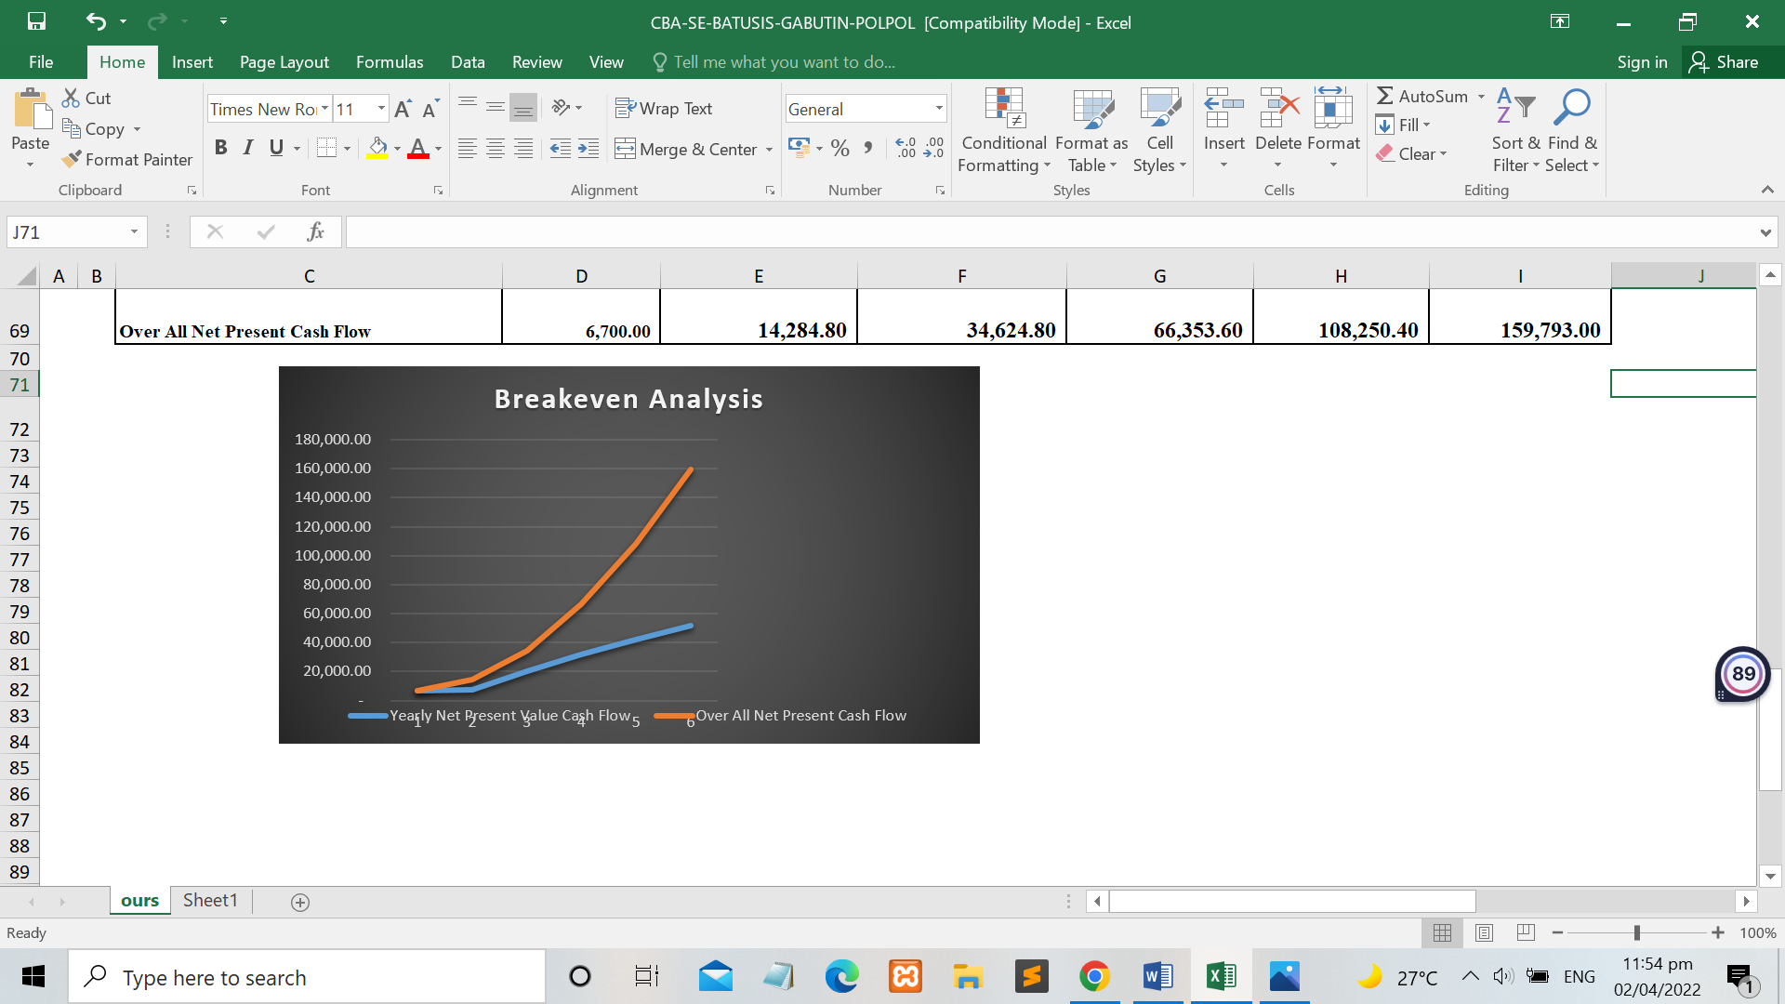**Graphical Presentation:**

66| P a g e

**Appendix E**

Screen Layout

67| P a g e

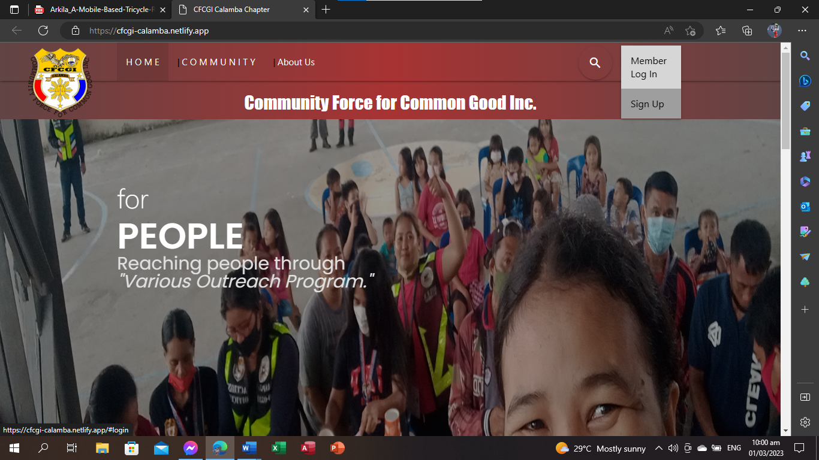

**Home Front Page**

68| P a g e



**Registration Form**

69| P a g e



**Sign-in Page**

70| P a g e

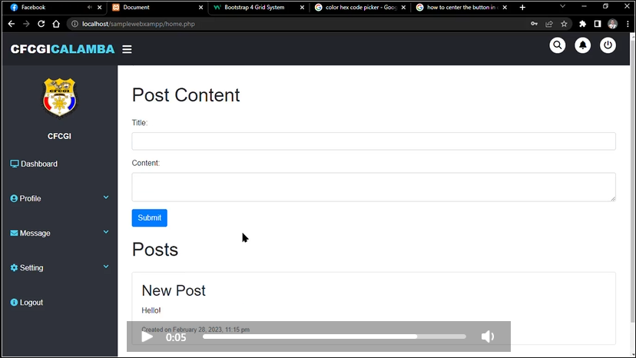

**Member Dashboard**

71| P a g e

**Admin Dashboard**

72| P a g e

**Appendix F**

Certificates

73| P a g e

**ADVISER’S CERTIFICATE**

This is to certify that the undersigned has reviewed and went through all the pages of the Capstone Project entitled “**An Official Website for Community Force for Common Good Incorporated – Calamba Chapter”** prepared and submitted by Maria Abegail M. Batusis, Mark Russel A. Mechilina and Mark Topher A. Villaluz, signed with the set of structural rules that govern the composition of the system and documents of the Capstone Project.

Signed this ___ day of ___ in the year of our Lord 2023 at St. Vincent College of Cabuyao.

**Signed:**

**ENGR. SHEILA MAE R. BISNAR**

Thesis Adviser

74| P a g e

**STATISTICIAN CERTIFICATE**

This is to certify that the undersigned has reviewed and went through all the pages of the Capstone Project entitled “**An Official Website for Community Force for Common Good Incorporated – Calamba Chapter”** prepared and submitted by Maria Abegail M. Batusis, Mark Russel A. Mechilina and Mark Topher A. Villaluz, signed with the set of structural rules that govern the composition of the system and documents of the Capstone Project.

Signed this ___day of ___ in the year of our Lord 2023 at St. Vincent College of Cabuyao.

Signed:

**MR. MARK RYAN CAPACIO, PhD**

Statistician

75| P a g e

**GRAMMARIAN CERTIFICATE**

This is to certify that the undersigned has reviewed and went through all the pages of the Capstone Project entitled “**An Official Website for Community Force for Common Good Incorporated – Calamba Chapter”** prepared and submitted by Maria Abegail M. Batusis, Mark Russel A. Mechilina and Mark Topher A. Villaluz, signed with the set of structural rules that govern the composition of the system and documents of the Capstone Project.

Signed this ___ day of ___ in the year of our Lord 2023 at St. Vincent College of Cabuyao.

Signed:

**MS. CAROL JANE PALAMARA**

Grammarian

76| P a g e

**FINANCIAL CERTIFICATE**

This is to certify that the undersigned has reviewed and went through all the pages of the Capstone Project entitled “**An Official Website for Community Force for Common Good Incorporated – Calamba Chapter”** prepared and submitted by Maria Abegail M. Batusis, Mark Russel A. Mechilina and Mark Topher A. Villaluz, signed with the set of structural rules that govern the composition of the system and documents of the Capstone Project.

Signed this ___ day of ___ in the year of our Lord 2023 at St. Vincent College of Cabuyao.

Signed:

**EDUARDO B. TUQUILAR _**

Financial

78| P a g e

**Appendix G**

Curriculum Vitae

79| P a g e

**Batusis, Maria Abegail M.**

*Birthdate:* October 21, 2000

*Height / Weight:* 5’4 / 60 kg

*Address:*163 Banaybanay Cabuyao, Laguna

*Mobile Number:* +639504172152

[abglbtss@gmail.com](mailto:abglbtss@gmail.com) . [www.facebook.com/gailbatusis](http://www.facebook.com/gailbatusis)

**EXPERIENCE**

* **2018 On the job training**

VAC Gate 2 Technopark Santa Rosa Laguna

* **2019 - Present Service Crew**

Greenwich SM City Santa Rosa Laguna

**EDUCATION**

* 2019-2023

BACHELOR OF SCIENCE IN INFORMATION TECHNOLOGY

ST. VINCENT COLLEGE OF CABUYAO

* 2017-2018

INFORMATION CAOMMUNICATION AND TECHNOLOGY

SCIENCE TECHNOLOGY INSTITUTE (STI) SANTA ROSA

* 2013-2016

SECONDARY, CABUYAO INTEGRATED NATIONAL HIGH SCHOOL

* 2007-2012

PRIMARY, PULO ELEMENTARY SCHOOL

**TECHNICAL SKILL**

* COMPUTER LITERATE
* BASIC MICROSOFT OFFICE
* BASIC KNOWLEDGE IN PHOTOSHOP
* BASIC KNOWLEDGE IN HTML, CSS & PHP

80| P a g e

**Villaluz, Mark Topher A.**

*Birthdate:* November 05, 1998

*Height / Weight:* 5’6 / 65 kg

*Address:* Blk 49 Lt 28 Buenavista Executive Homes,

Brgy. Batino Calamba, laguna

*Mobile Number:* +63 965 278 9385

**Core competencies**

* Persuasive Speaking Skills
* Ability to Use Positive Language
* Adaptability
* Clear Communication Skills
* Effective Listening
* Time Management
* Willingness to Improve
* Teamwork/Collaboration
* Critical Thinking/Problem Solving

**EDUCATION**

* 2017-2018 ALS (Alternative Learning System) Graduate
* 2018-2022 BSIT (Bachelor of Science in Information Technology)

**TECHNICAL SKILL**

* Computer Literate (Microsoft Office,

Computer Hardware, Software)

* Basic Web Development (HTML, CSS, MySQL, Java)
* Basic Graphic Designing

81| P a g e